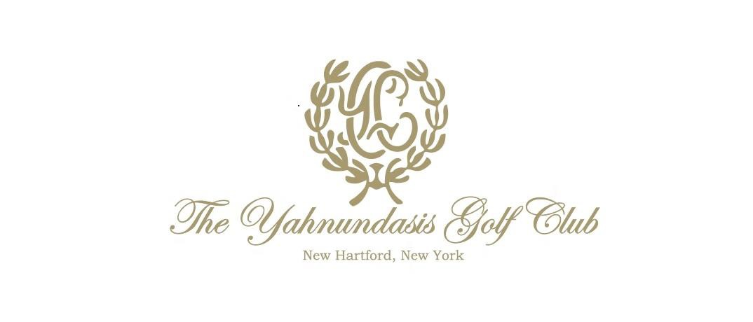
MEMBERSHIP APPLICATION FORM

YAHNUNDASIS GOLF CLUB
SENECA TURNPIKE, NEW HARTFORD, NY 13413 CLUBHOUSE – 315-732-6123 FAX – 315-732-5439

CLASS OF MEMBERSHIP TO BEGIN AFTER 4/30/18
- RESIDENT - SINGLE
- RESIDENT – HOUSEHOLD
- ASSOCIATE - (Ages 21-29)
- ASSOCIATE - (Ages 30-35)
- ASSOCIATE - (Ages 36-40)
- RESIDENT- SOCIAL
- ASSOCIATE SOCIAL – (Ages 21-30)
- ASSOCIATE SOCIAL – (Ages 31-40)

Dues Billing Preference _____Annual

_____Monthly

CANDIDATE INFORMATION - CONFIDENTIAL

Primary Member Mr. Mrs. Ms. Dr.

Preferred Name Jr. Sr. Date of Birth

Home Address

City State Zip

Home Phone Fax Mobile

Marital Status Single Married Wedding Anniversary Date

Social Security # Driver’s License #_ State

Business Name Type of Business

Title Length of Employment (years) Business Address
City State Zip

Business Phone Business Fax

Please send e-mails to this address

MEMBER PRIMARY SPONSORS

Name (Signature required)

Name (Signature required)

FAMILY INFORMATION:

Spouse Name Date of Birth

Cell Phone

Please send e-mail to this address

DEPENDENT CHILDREN (Unmarried children under 23 residing with Candidate) Name(s) Date of Birth

CREDIT CARD AUTHORIZATION FOR ACCOUNT

I agree to enroll in Autopay on the Plastiq website (yahnundasis.plastiq.com). I will maintain a current credit/debit card account through Plastiq and hereby authorize said credit/debit card to be charged on the 10th of every month. Members will be allowed to sign for member charges in our Clubhouse Restaurant and Golf Shop.

Valid email address for registration:

Signature of Agreement Date

By signing and submitting this form, I understand that the election to Membership in The Yahnundasis Golf Club is expressly conditioned upon the approval of the Board of Governors. I agree and consent that The Yahnundasis Golf Club may investigate my personal and employment background, credit status and inquire into other matters concerning my record of financial and personal responsibility. If I am elected to Membership, I agree to remain a Member of the Club for the initial 12 months of my Membership provided that the annual dues billed to my account remain the same for such period.

Please check ONE:
I do _____ I do (not)______ give consent/permission to use photographs that the Yahnundasis may take or use photographs of me with or without my name and for any lawful purpose, including for example such purposes as Facebook, Instagram, Publicity, Illustration, Advertising, and Web Content

Applicant (Signature required)

Date

Congratulations & Welcome! After your application, has been processed, Jen Stone will be in contact with to meet you at the club and provide you with a guided tour and answer any questions you may have.

