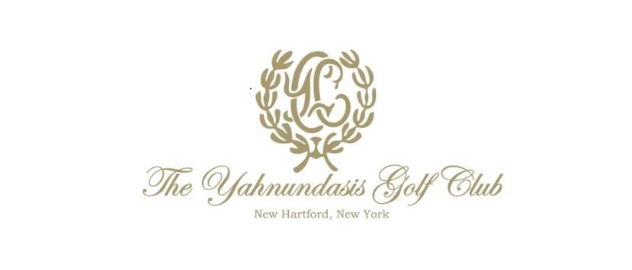

SPRING/SUMMER 2018 MEMBERSHIP INITIATIVE

Our club has experienced tremendous growth and improvement over the past year. Our clubhouse is turning out great food, a warm atmosphere, and a schedule of events which has peaked our members’ interest. The golf course has returned to its true form. We feel that there is no better time to welcome new members to our club, however we don’t want them to take our word for it. Now is the time to have them come and experience it!

A two-year promotion dues schedule would be as follows -

The Year One New Member Annual Dues are as follows - (which can be billed monthly with exception of Corporate Social)

Resident Household Golf: | $4,199.00 | or $349.95 month
Resident Single Golf: | $3,600.00 | or $300.00 month
Associate Golf (Ages 21-29): | $1,800.00 | or $150.00 month
Associate Golf (Ages 30-35): | $2,399.40 | or $199.95 month
Associate Golf (Ages 36-40): | $2,999.76 | or $249.98 month
Resident Social:  Associate Social (Ages 21-30):  Associate Social (Ages 31-40): | $1,499.40  $900.00  $1140.00 | or $124.95 month  or $75.00 month  or $95.00 month
Corporate Social: | $3,900.00 | ---
In Year One of New Membership Locker ($200.00 Annually) & Pro Shop Services ($100.00 Annually) will be provided at no charge to all golfing members.

Range Memberships are available for purchase for $125.00 Annually, or member can choose to pay per use.

In Year One of New Membership, no Restaurant Minimums will be required.

The Year Two New Member Annual Dues are as follows - (which can be billed monthly with exception of Corporate Social)
Resident Household Golf: | $4620.00 | or $385.00 month
Resident Single Golf: | $4000.08 | or $333.34 month
Associate Golf (Ages 21-29): | $1980.00 | or $165.00 month
Associate Golf (Ages 30-35): | $2640.00 | or $220.00 month
Associate Golf (Ages 36-40): | $3299.04 | or $274.92 month
Resident Social: | $1650.00 | or $137.50 month
Associate Social (Ages 21-30):  Associate Social (Ages  31-40):  Corporate Social: | $1080.00  $1368.00  $4290.00 | or $90.00 month  or $114.00 month  ---

In Year Two of New Membership Locker ($200.00 Annually Pro Shop Services ($100.00 Annually), & Range ($125.00 Annually) will only be charged to golf members who choose to utilize these services.

In Year Two of New Membership, a $750.00 Annual Restaurant Minimum will be required.

There will be no initiation fees required for new members.

Hole in one insurance ($25.00 Annually) is charged to all golfing members.

Golf Handicap & Information Network – GHIN ($35.00 Annually) is charge to all golfing members.

All prices require Oneida County Sales tax to be added.

After the two-year promotion, rates will be adjusted to standard membership rates/policies.

Membership Class Description

Members shall be elected to the different classifications of membership as follows:

- Resident Membership: Resident Members shall be elected from persons who are at least
forty-one years of age and live within a radius of ninety miles from the Club (hereinafter called the “residential area”) or are employed or have a place of business within said area.

Resident Classes:

Resident Household Membership provides use of all Club facilities for the Member, a spouse and their unmarried children under 23.

Resident Single Membership provides use of all Club facilities for the Member and use of the Clubhouse and athletic facilities, excluding golf, for a spouse and unmarried children under 23.

- Associate Membership provides use of the Club facilities for the Member, a spouse and their unmarried children under 23. Associate Members shall be elected from persons eligible to Resident Membership who is under forty-one years of age. On the first day of the month following the date when an Associate Member shall reach forty-one years of age, an Associate Member must elect to be transferred to a class of Membership to which eligible or resign from the Club.

- Resident Social Membership Social Members shall be elected from persons eligible to Resident Membership. This Membership provides use of the Club’s facilities and amenities to include the championship 18-hole golf course (limited to four rounds per year, subject to applicable guest fees), tennis courts, aquatic facility, clubhouse, dining and all social related events, for the Member, spouse and unmarried children under 23.

- Associate Social Membership - provides use of the Club’s facilities and amenities to include the championship 18-hole golf course (limited to four rounds per year, subject to applicable guest fees), tennis courts, aquatic facility, clubhouse, dining and all social related events, for the Member, spouse and unmarried children under 23. On the first day of the month following the date when an Associate Member shall reach forty-one years of age, an Associate Member must elect to be transferred to a class of Membership to which eligible or resign from the Club.

- Corporate Social Membership On an annual basis, a Corporation or Business entity may be permitted to sponsor five (5) of its officers or managers who may use the Club’s facilities and amenities to include the championship 18-hole golf course (limited to four rounds per year, subject to applicable guest fees), tennis courts, aquatic facility, clubhouse, dining and all social related events. Within such annual period, substitutions of the designated Members may be permitted only with Board approval upon condition that the designated member has transferred beyond the resident area or terminated his or her employment with the corporate/business member.

Restaurant Minimum and Service Charge:
Based upon our fiscal year of September 1st through August 31st, there is an annual restaurant minimum purchase requirement of $750. The Club automatically adds a 20% service charge to each bill. The restaurant minimum will be prorated from the time that Membership commences up to April 1st (e.g., assuming an April 1st membership, the restaurant minimum would be
$312.50). Unused restaurant minimums will be billed to the Membership account.

Significant Other Policy:
Privileges to use the golf and house facilities are extended to an individual nominated by a Member to be a “significant other” of the Member, conditioned upon the qualification set forth below and the payment of the annual fee as hereafter provided. In order to qualify, the Member and “significant other” must both be unmarried. The Member may only designate one “significant other” per fiscal year. All purchases made and charges incurred by the “significant other” shall be the sole responsibility of the Member. Unless the children of the “significant other” cohabit with the Member, neither they nor relatives of the “significant other” shall have independent rights to use the golf or house facilities, but may be treated as “guests” of the Member subject to limitations specified in the By-Laws and House Rules.

Reinstatement Policy:
Resigned Members within the previous 12 months can apply for reinstatement and upon approval may be reinstated at the level of Membership they held upon resignation. Consistent with our policy, they will however be obligated to pay back dues for the months they were resigned.

Member References:
Please provide two references to be reviewed by the Membership Committee and Board of Governors. The references are to be listed on your Membership Nomination Profile (member application form).

Credit Card for Past Due Accounts:
All new members must maintain a current credit card account on file at Yahnundasis.plastiq.com. Should your account become delinquent, the Club shall have the right to bill such past-due amount to the credit card. Autopay Enrollment is available for easy settlement of account on the 10th of each month.

Questions:
For questions regarding the above described Membership Classifications, please feel free to contact the Club at (315) 732-6123.

